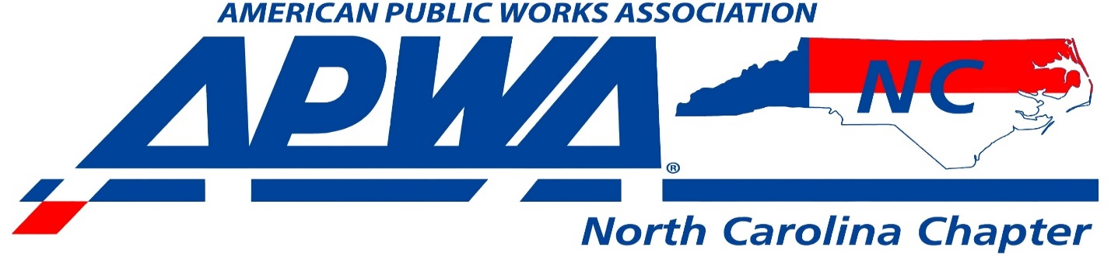
WHAT: 2022 NCAPWA Backhoe Rodeo
WHEN: Wednesday April 27, 2022
NOTE: This will coincide with the Mid Atlantic Spring Equipment Show by Godwin
WHERE: Gov. James B. Hunt Jr. Horse Complex, 4601 Trinity Road Raleigh, NC
COMPETITION: This is our state competition to see who will represent NCAPWA at PWX 2022 later this year in Charlotte NC! We will have multiple brands of machines set up for the competition. When you arrive at the registration desk you will be given a time slot in which you are required to return and compete. You will draw a chip from a bucket that will designate which machine you are to compete in. There will be a practice time for competitors to come and get familiar with the different machines that will be used for the competition. If you do not show up for your designated time slot you will be disqualified. Please send a list of competitors you are sending to emanning@godwin-group.net
